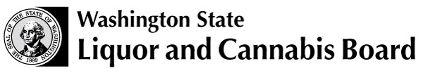 | Licensing and Regulation  1025 Union Ave SE  PO Box 43098  Olympia WA 98504-3098  Phone: 360 664-1600  Fax: 360 753-2710  www.lcb.wa.gov
 |  | License Number
 |  | Trade Name
 |  | UBI Number

SPIRITS RETAILER SAMPLING ENDORSEMENT ACKNOWLEDGMENT

Please sign below that you have read and understood all of the following requirements:

- I am a member of the Responsible Vendor Program (RVP).

- I am required to send a list of scheduled spirits samplings to my regional enforcement office at the beginning of each month. The date and time for each spirits sampling must be included.

- All employees whose duties include serving spirits during sampling activities must hold a Class 12 Mandatory Alcohol Server Trainer (MAST) permit.

- Advertising
For Spirits Retail licenses that also hold a Grocery Store license:
- Signs advertising spirits samplings may not be placed in the windows or outside of the premises that can be viewed from the public right of way.

For Spirits Retail licenses that also hold a Beer/Wine Specialty Shop license:
- Advertising of spirits sampling may be advertised but may not state sampling is free of charge.

- I may provide, free or for a charge, no more than one-half (1/2) ounce serving of spirit samples and no more than one-and-a-half (1 1/2) ounces total of spirits samples per person during any one visit to the premises. Only one sample of the same product offering of spirits may be provided to a customer during any one visit to the premises.

- I must have food available for the tasting participants.

- The service area and facilities must be located within my fully enclosed retail area. The retail area must be of a size and design in which employees can observe and control persons in the area to ensure that persons under 21 years of age and apparently intoxicated persons do not possess or consume alcohol. Customers must remain in the service area while consuming samples.

- Fixed or movable barriers are required around the tasting area to ensure persons under 21 years of age do not possess or consume alcohol.

- I must have at least two employees on duty any time I am conducting spirits sampling events. One of those employees must be dedicated to the spirits sampling events when they are conducted.

Print Name
Signature |  | Date

